Name: Ritika Mohan
Prn: 23070521183
Semester: 5th C (C1)
Aim String Methods & Regular Expressions:
Work with string functions like split(), match(), replace(), indexOf(). Use regex to validate an email and extract information. Count vowels and reverse a given paragraph.
Output:
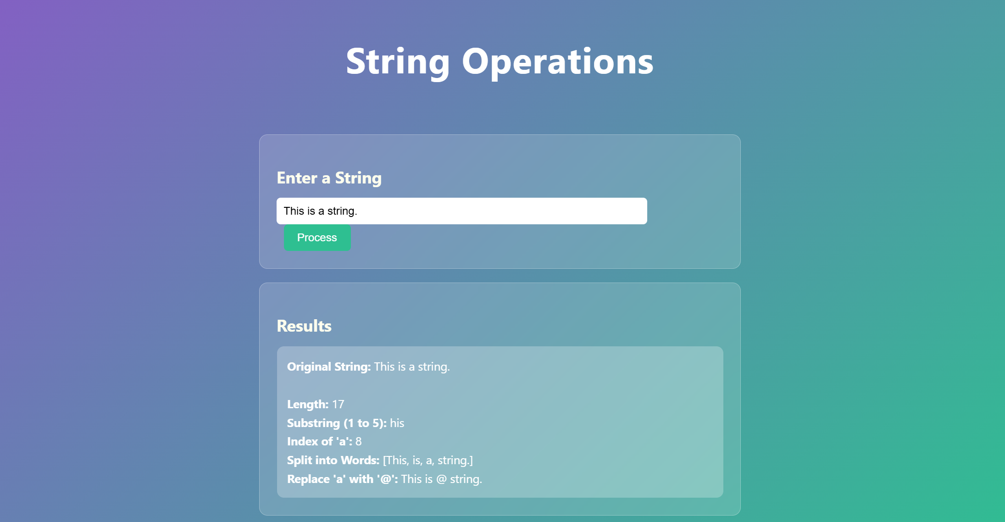
Conclusion: Hence Used regex to validate an email and extract information , Count vowels and reverse a given paragraph.

